**CREATING POSTGRES TABLE:**

I have used the Loan Prediction dataset to create the Postgres table. You can download the dataset from the link below.

https://datahack.analyticsvidhya.com/contest/practice-problem-loan-prediction-iii/

**Step 1:** Write the query tool as follows

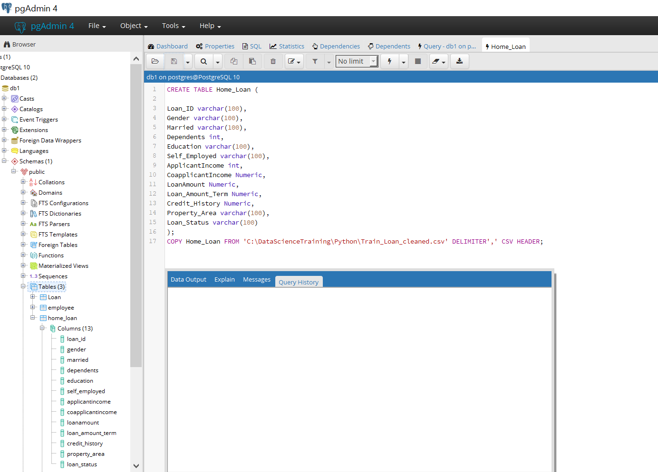

**Step 2:** To view the list of tables in your database including the table that you created above use the following commands

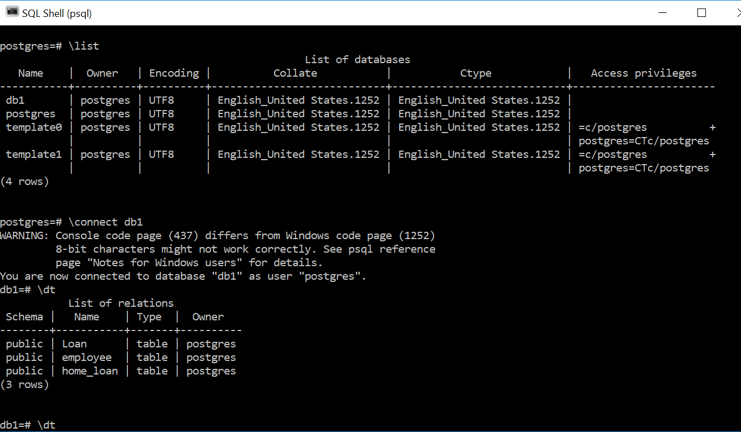

**Reading Data in Pandas Data frame from Postgres Table:**

Step 1: Install the Python package ‘pscycopg2’ in your anaconda prompt using the following command.

**pip3 install psycopg2**

Also, you can use ‘pygresql’ package to connect PostgreSQL databases using Python. Use the following command to install it

**pip install pygresql**

To set up a Python virtual environment (using SSH) and install the above package follow the steps given in the below link

<https://www.a2hosting.com/kb/developer-corner/postgresql/connecting-to-postgresql-using-python>

To know more about connecting Postgres with Pandas and Jupyter refer the following link

<http://jgardiner.co.uk/blog/read_sql_pandas>

How to import Large data into Postgres SQL? Refer following Links

<https://www.youtube.com/watch?v=DGtJAJUIxXw>

<https://data36.com/sql-where-clause-tutorial-beginners-ep2/>